Step 1: create a vpc
Go to AWS Management Console → VPC Click Create VPC
- Choose VPC only
- Enter:
  - Name: Custom-VPC
  - IPv4 CIDR block: e.g. 10.0.0.0/16
- Click Create VPC
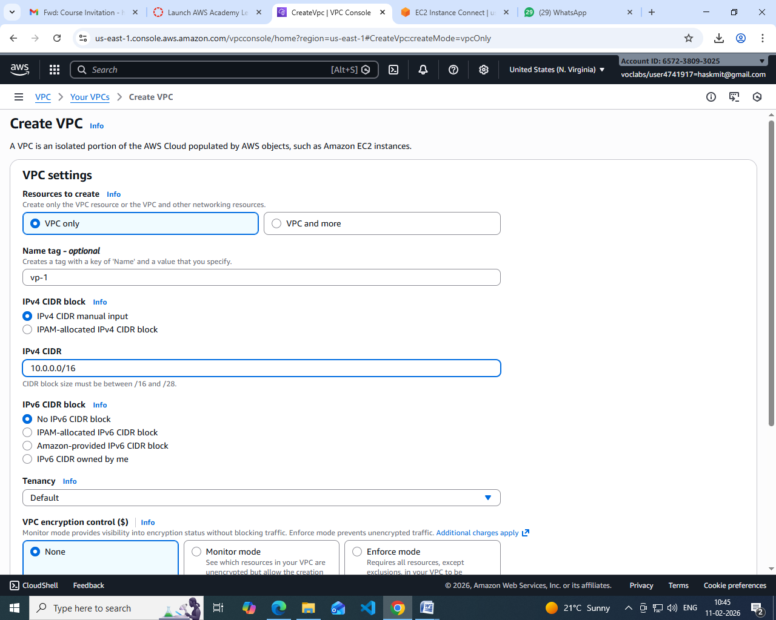

Step 2: Create Subnets (Public & Private)
- Go to Subnets → Create subnet
- Select your VPC
- Enter CIDR
- Create subnet
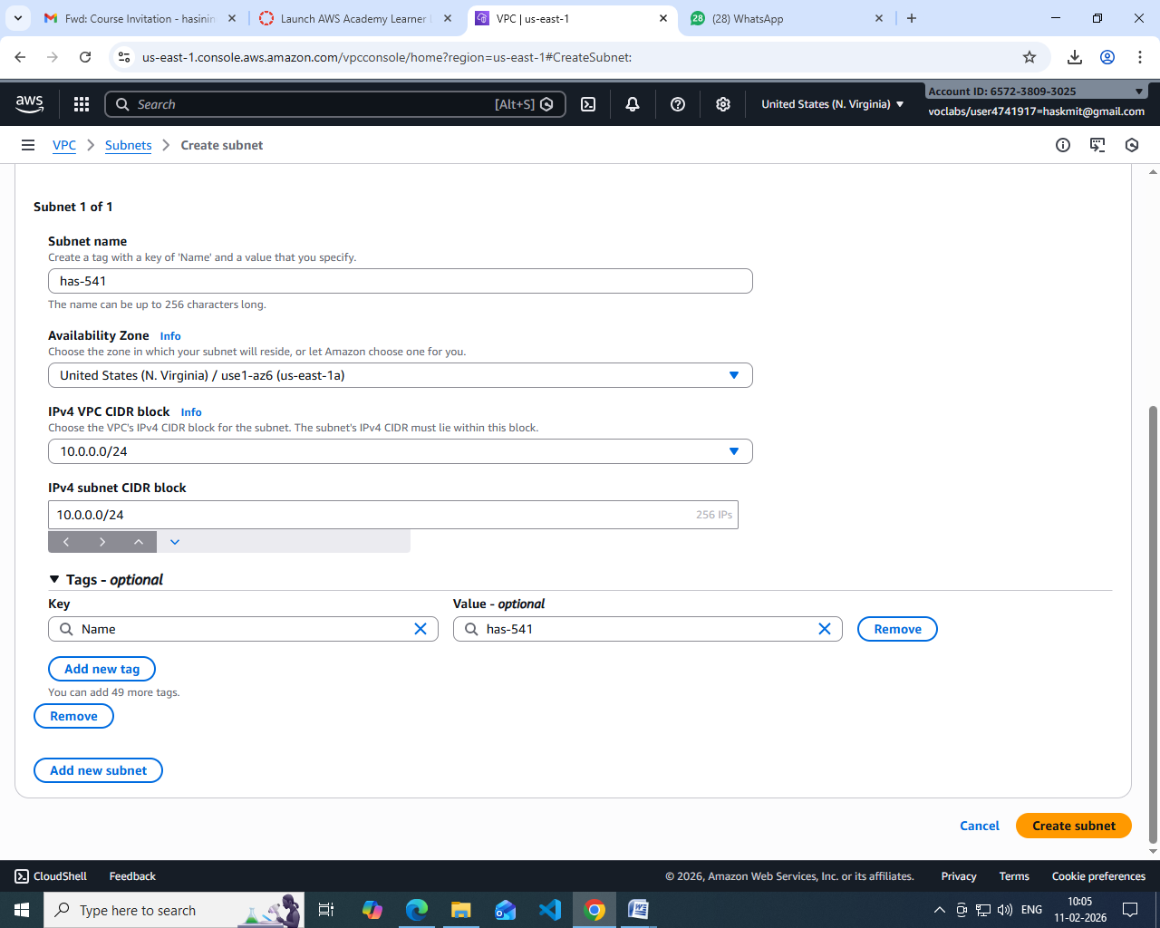

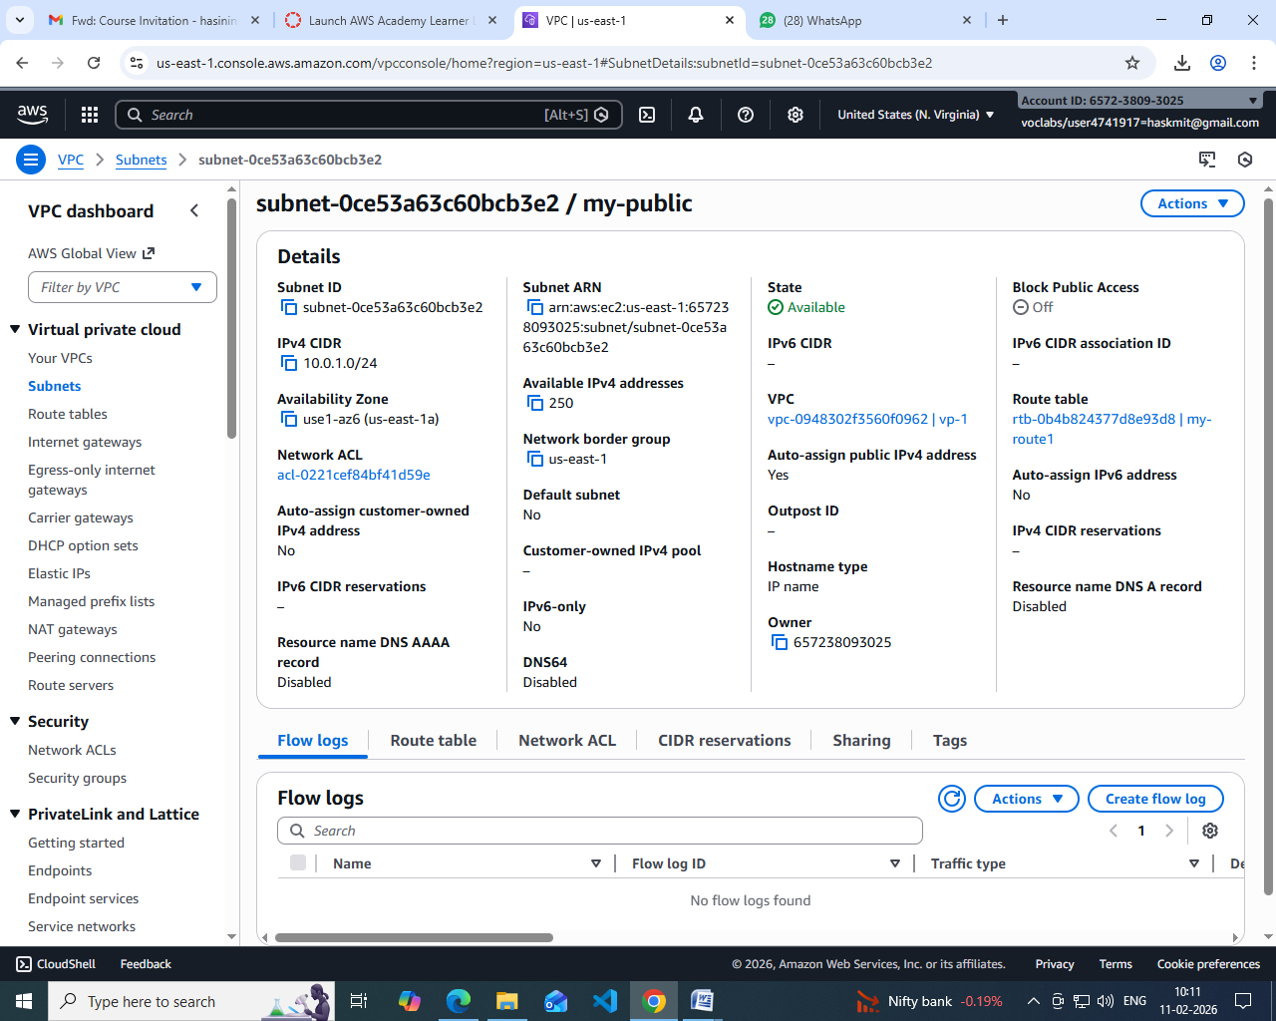
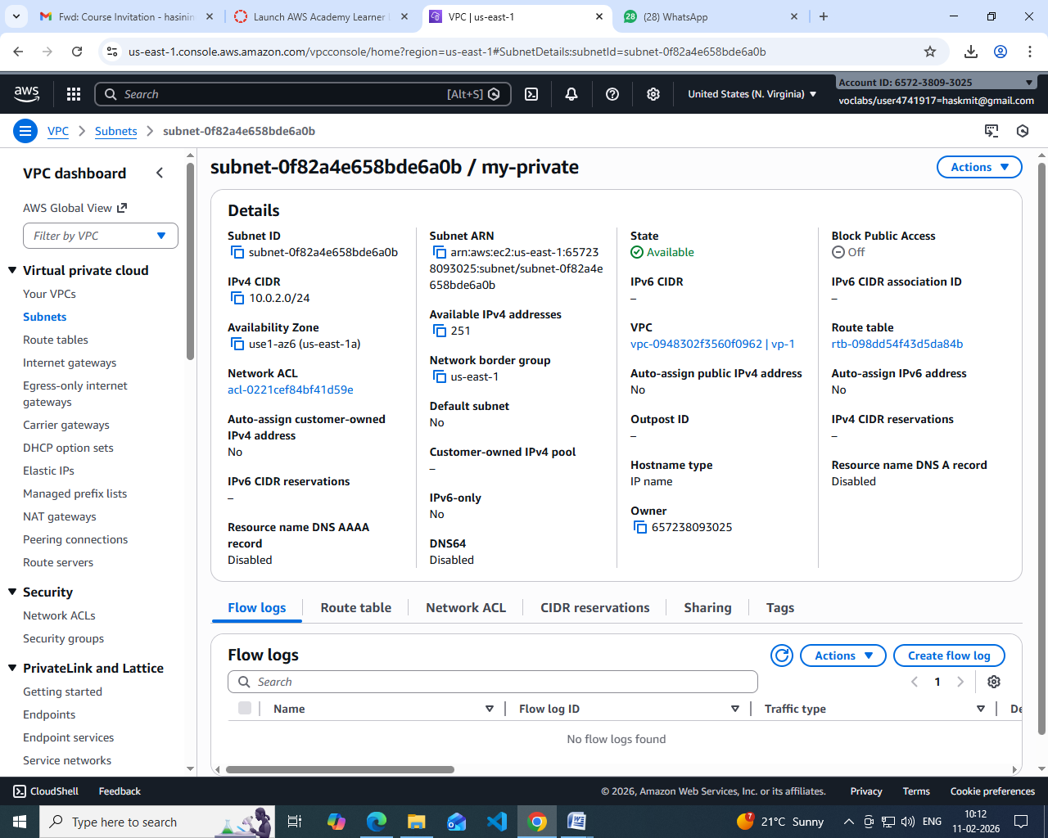

🔹 Step 3: Create an Internet Gateway (IGW)
- Go to Internet Gateways
- Click Create internet gateway
- Name it Custom-IGW
- Attach it to your VPC

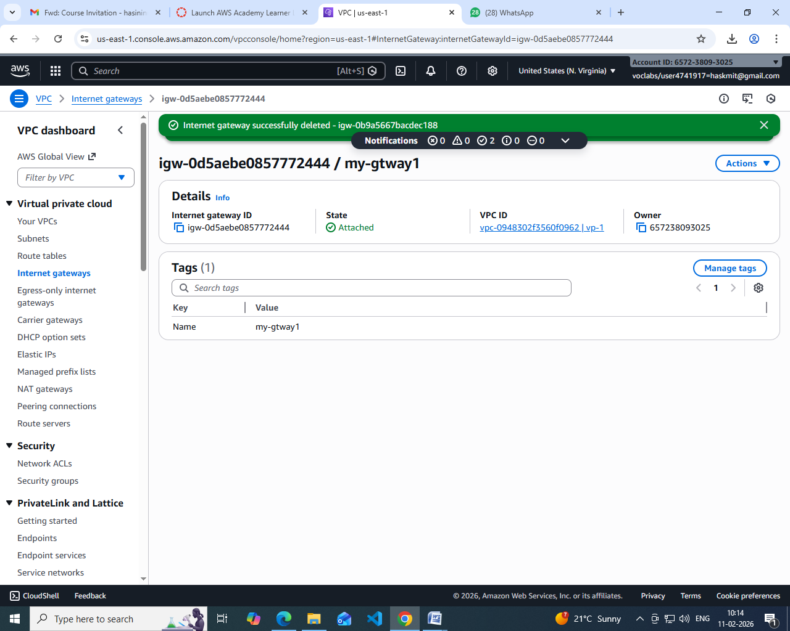

Step 4: Create Route Tables
You need separate route tables for public and private subnets.

Public Route Table
- Go to Route Tables → Create route table
- Select VPC
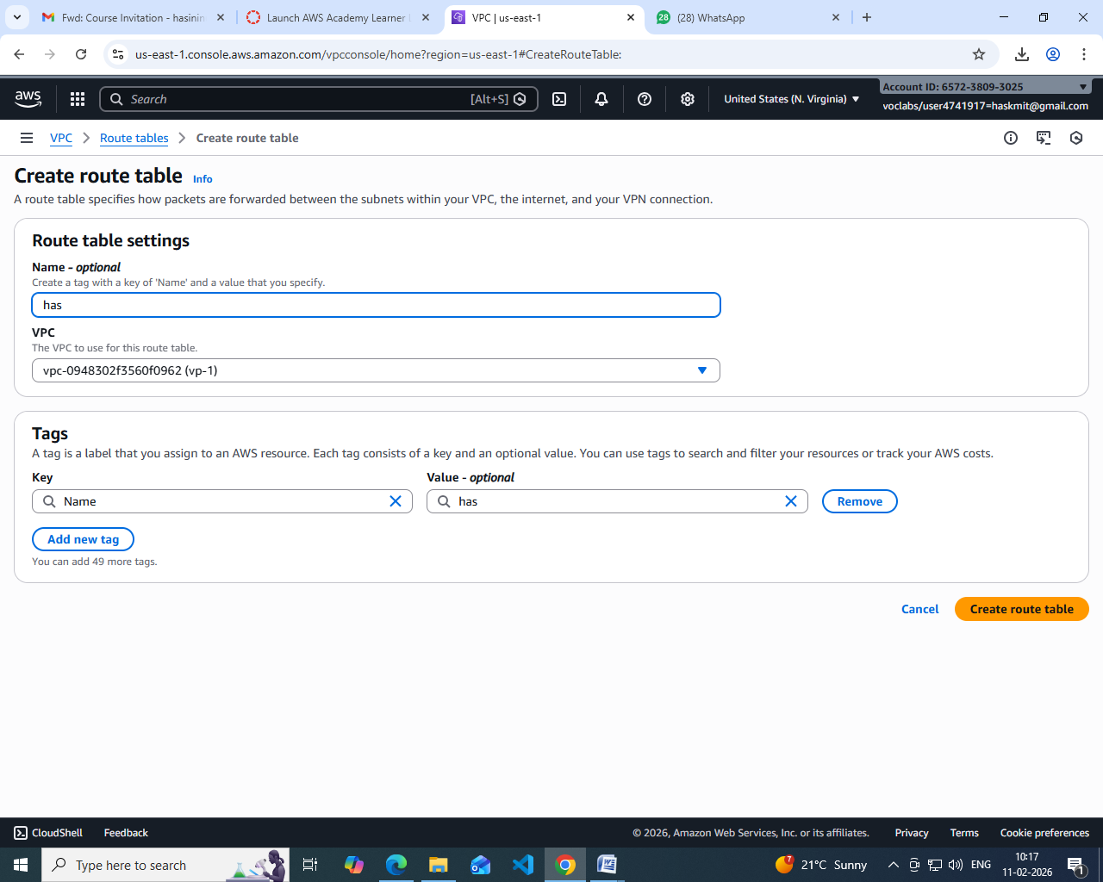

Add route:
  - Destination: 0.0.0.0/0
  - Target: Internet Gateway
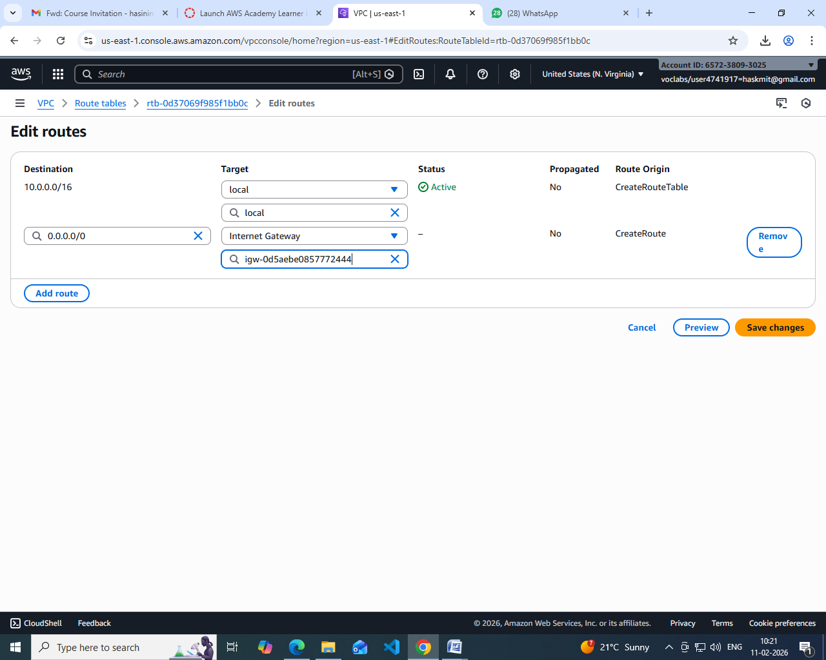
- Associate with public subnet
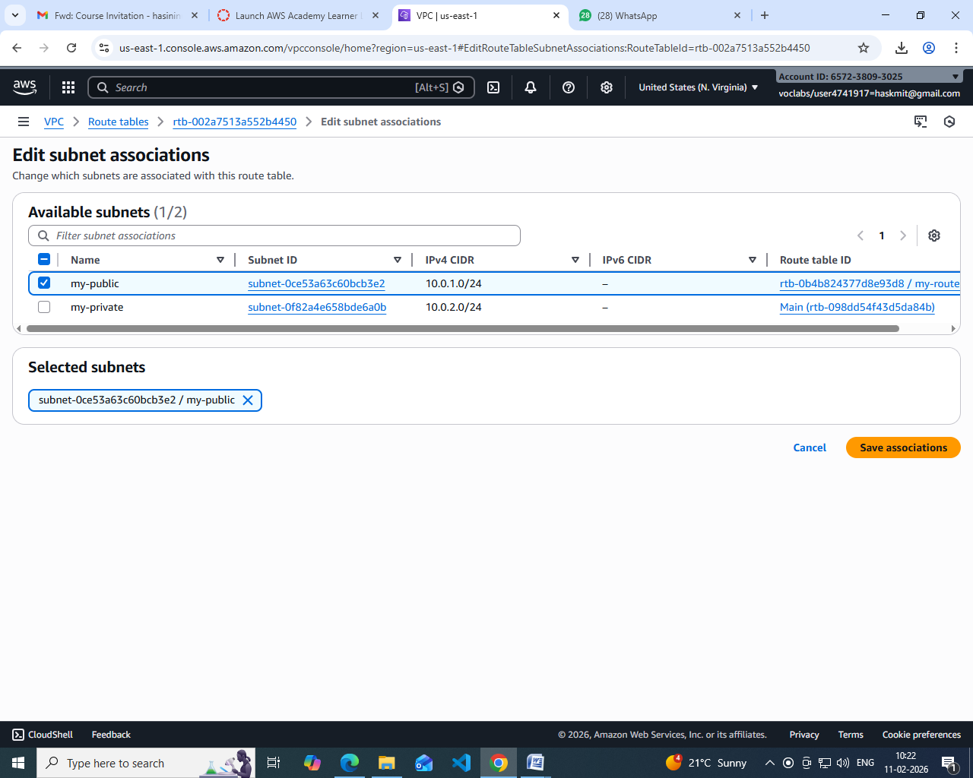

Enable Auto-Assign Public IP (Public Subnet)
- Select Public Subnet
- Go to Edit subnet settings
- Enable Auto-assign public IPv4 address

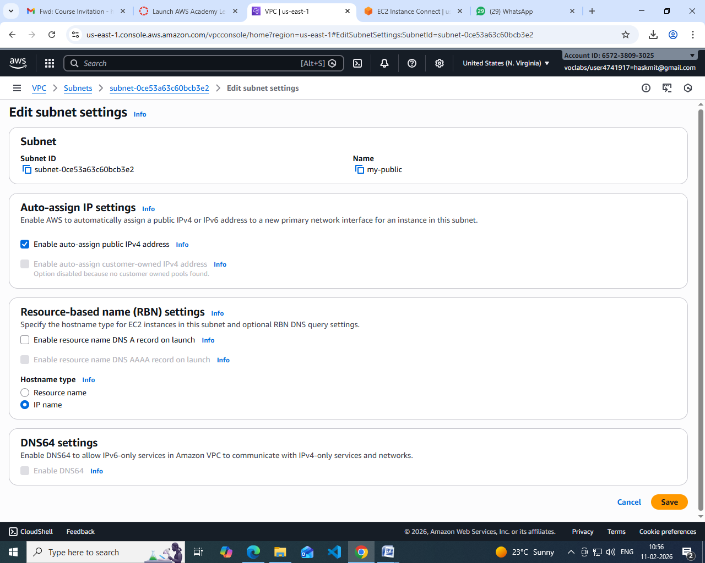

🔹 Step 6: Configure Security Groups
- Create a Security Group
- Add inbound rules:
  - HTTP (80) / HTTPS (443)
  - SSH (22) from trusted IP
- Attach to EC2 instances
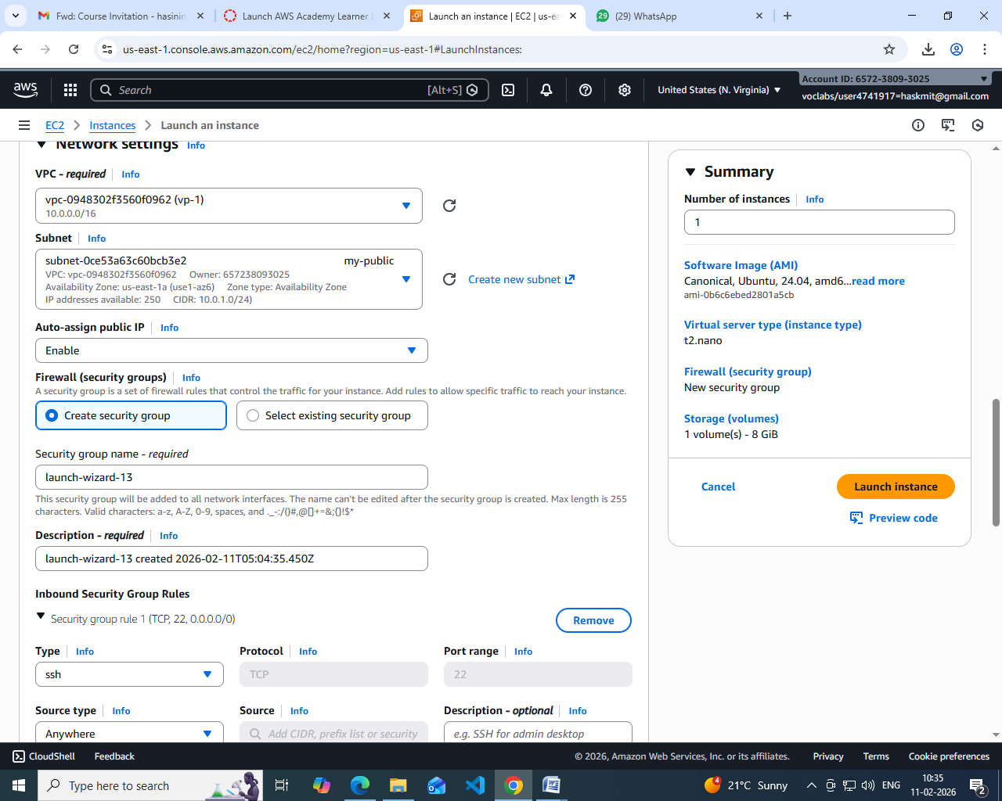

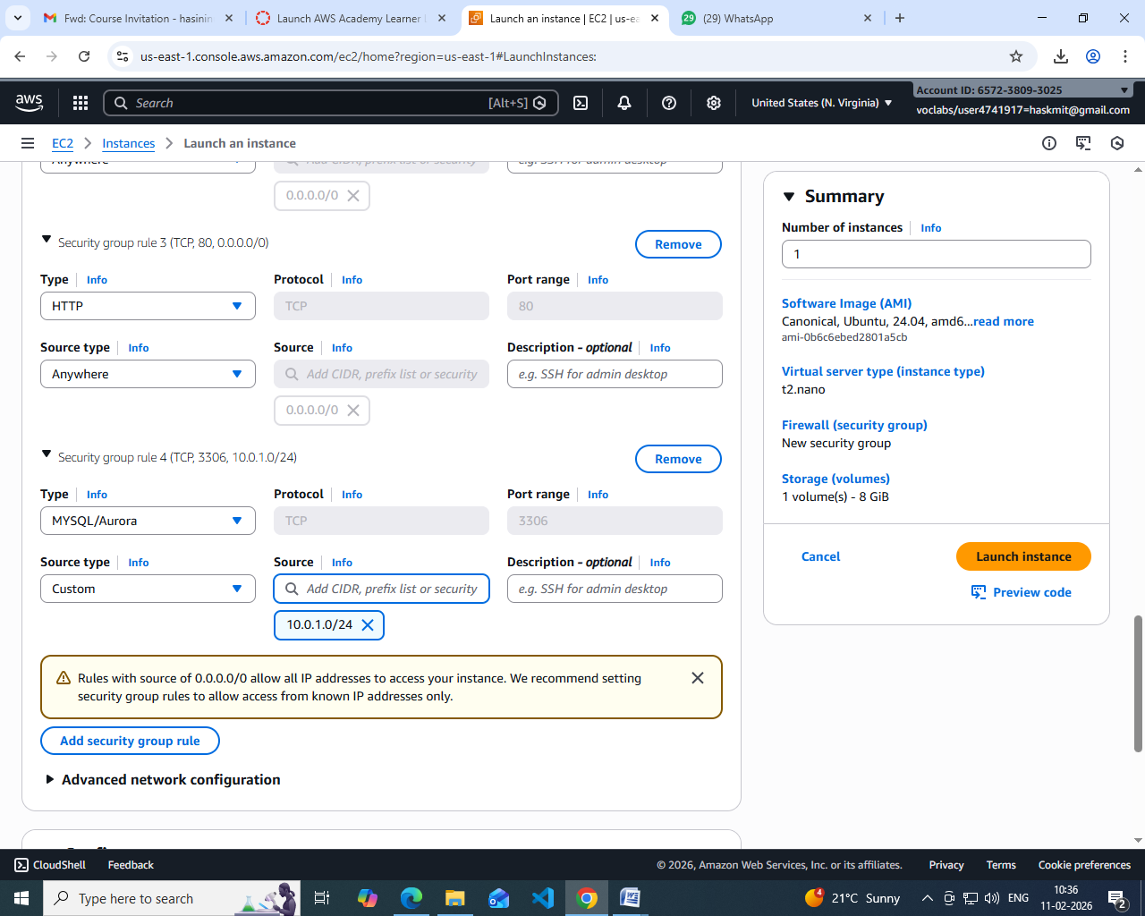

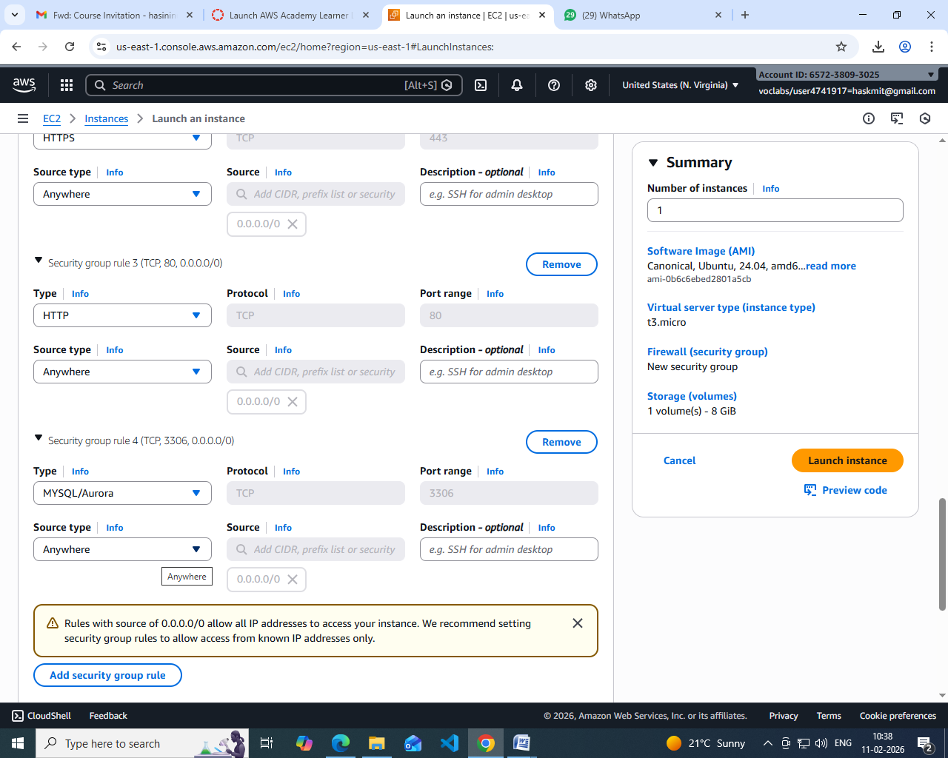

Step 7: Launch EC2 Instances
- Public EC2 → Public subnet
Private EC2 → Private subnet
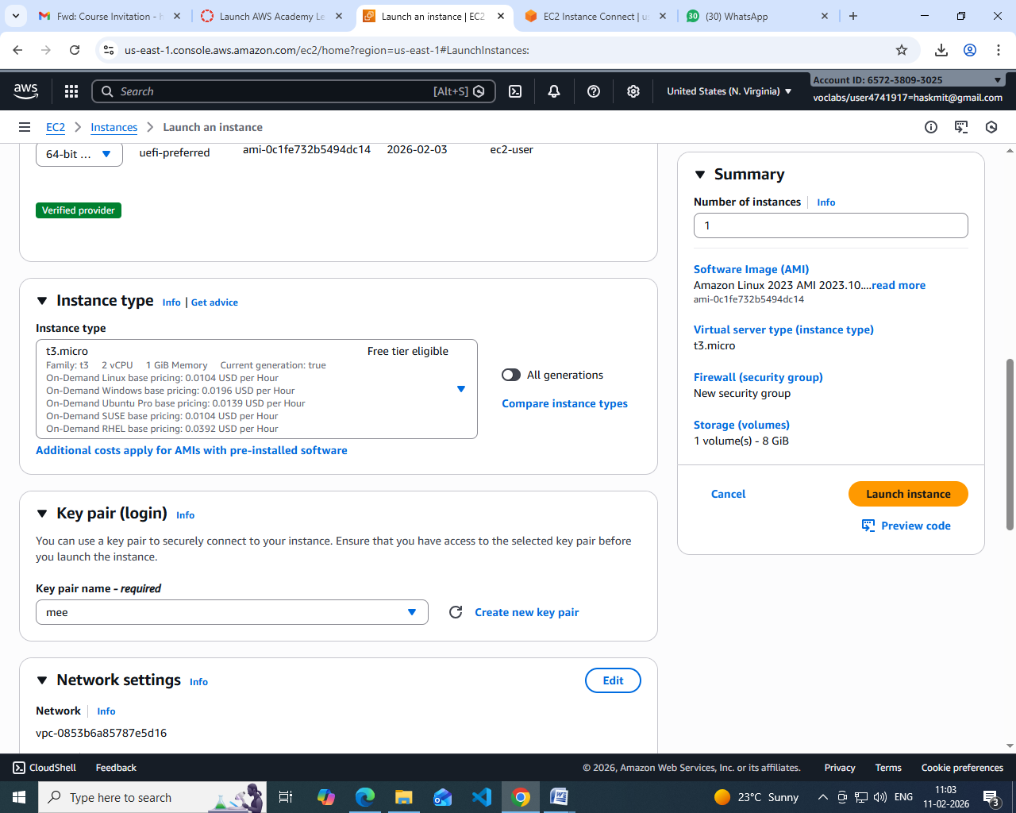

🔹 Step 8: Test the Setup
- Public EC2 → Internet access ✔
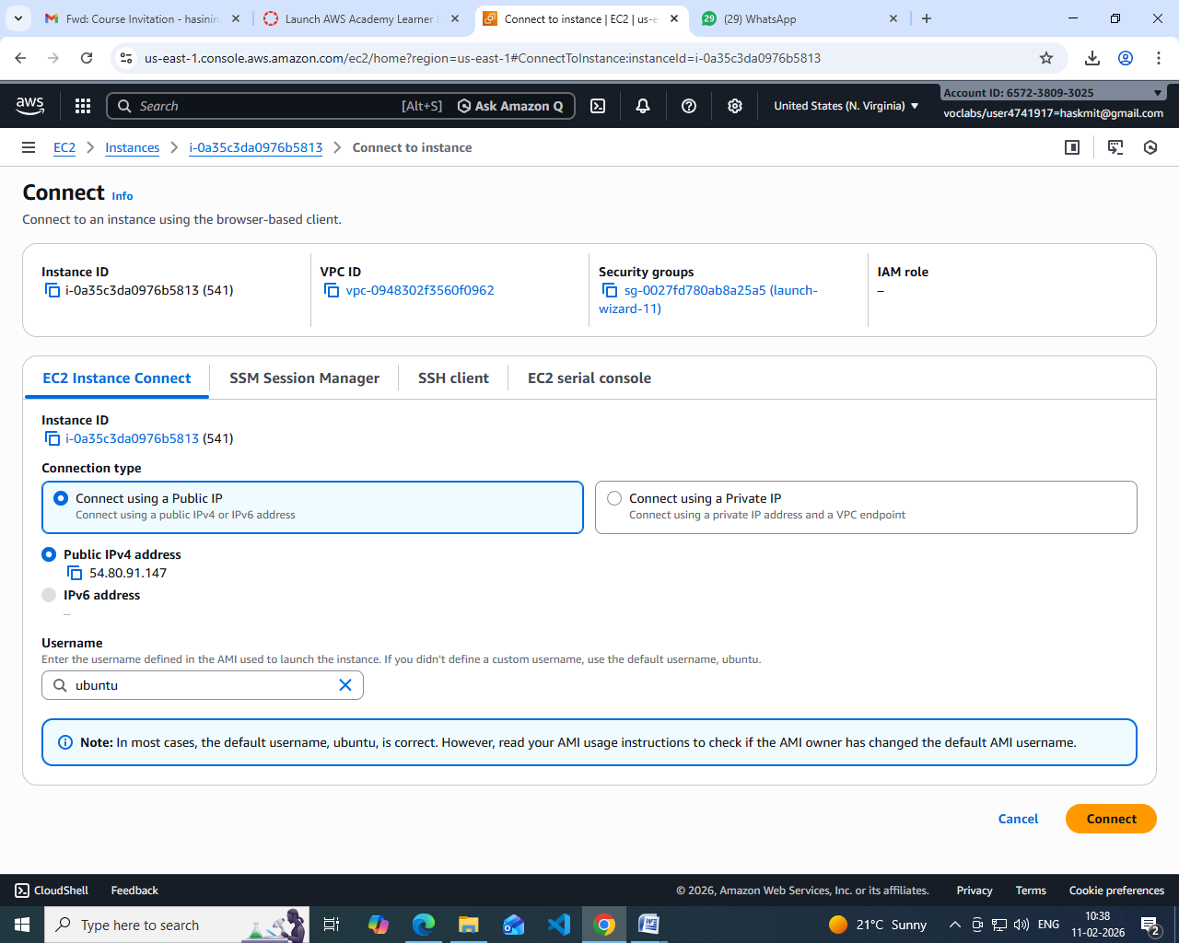
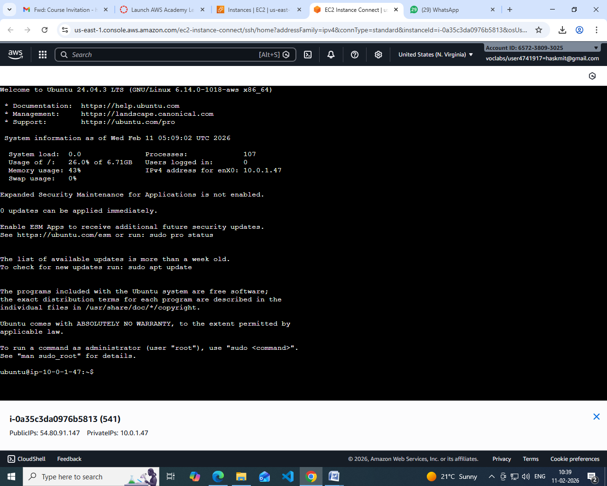
- Private EC2 → Internet via NAT ✔
- Private EC2 → No direct inbound access ✔

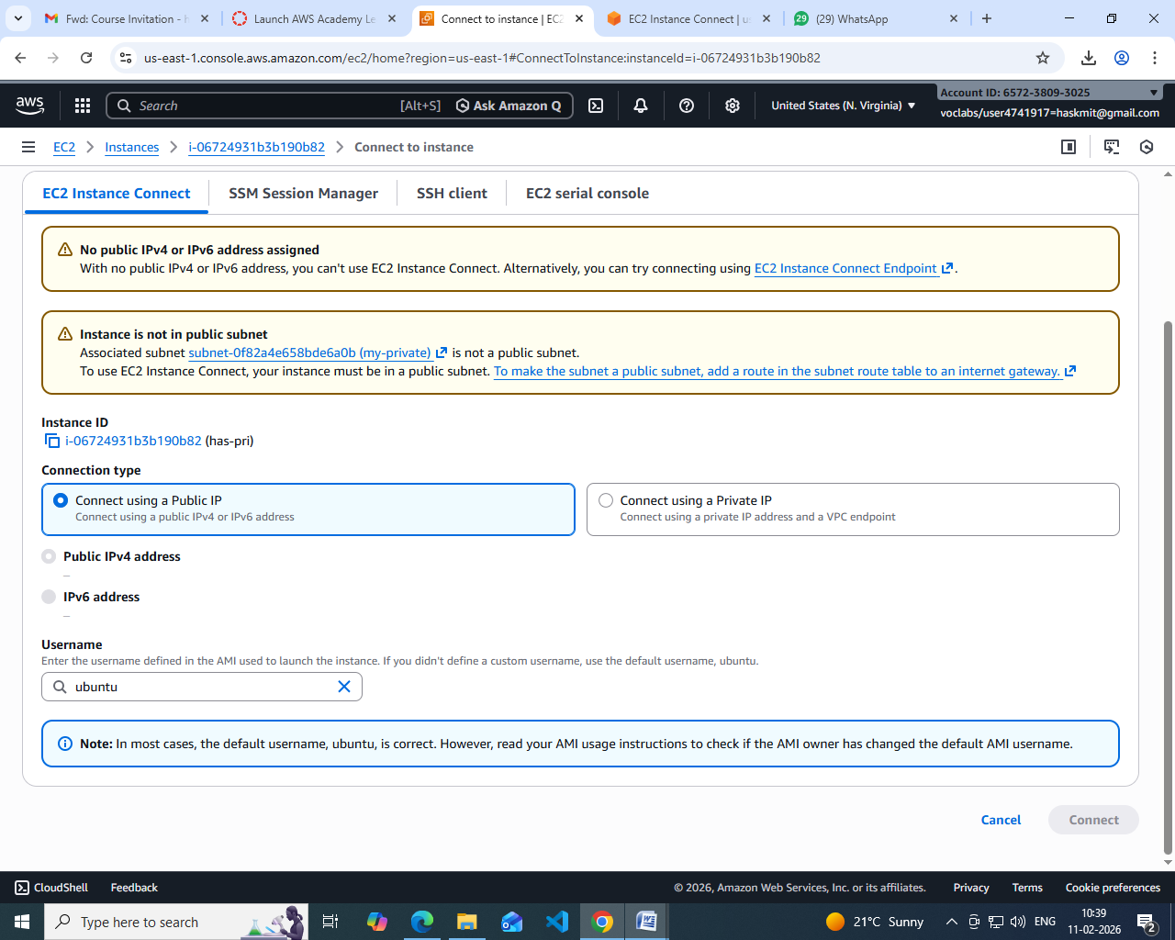
Scenario Based Questions:

- You have a web application where users access a website, but the database should not be exposed to the internet. How would you design the VPC? Which resources go into public and private subnets?
ANSWER:
Design the VPC so that web servers and load balancers are placed in public subnets with an Internet Gateway, while the database is placed in a private subnet without direct internet access. The web tier communicates with the database internally through private IPs, keeping the database secure.

- An EC2 instance in a public subnet cannot access the internet. What VPC components would you check and why?
ANSWER:
Check whether the VPC has an Internet Gateway attached, the subnet route table contains a default route to the IGW, the instance has a public or elastic IP, and ensure security groups or network ACLs are not blocking outbound traffic.

- Your application server needs to connect to an RDS database securely. How would you configure security groups and subnets?
ANSWER:
Both the application server and RDS should be in private subnets. Configure security groups so that the database allows inbound traffic only from the application server’s security group instead of open internet access.

- You are asked to design a VPC for 500 servers today, but it should scale to 2,000 servers in the future. How would you choose the CIDR block?
ANSWER:
Choose a large CIDR block such as /16 at the beginning because expanding CIDR later is difficult. A larger range ensures enough IP addresses for future scaling.
- A company wants secure connectivity between its on-premises data center and AWS VPC.Which AWS services would you choose and why (VPN vs Direct Connect)?
ANSWER:
Use VPN for quick, low-cost, internet-based connectivity suitable for small or medium workloads. Use Direct Connect for high bandwidth, low latency, and dedicated private connectivity required by large enterprises.

- You need to connect two VPCs, but both use the same CIDR range. How would you solve this problem?
ANSWER: Overlapping CIDR blocks cause routing conflicts. The best solution is to modify one VPC’s CIDR range or use NAT/PrivateLink solutions to avoid direct IP overlap.
- Multiple microservices running in different subnets need to communicate securely. How would you design routing and security groups?
ANSWER: Place services in private subnets and control communication using security groups that reference each other instead of open IP ranges. Routing should allow only internal traffic within the VPC.

- Design a VPC for a 3-tier application (Web, App, DB) with high security and scalability. Explain subnets, route tables, gateways, and security groups.
ANSWER:
Use public subnets for load balancers or bastion hosts, private subnets for application servers, and isolated private subnets for databases. Attach an Internet Gateway for public access and a NAT Gateway for private subnet outbound access, while security groups restrict traffic between tiers.
- You suspect unusual traffic inside your VPC. How would you monitor and analyze network traffic?
ANS:
Enable VPC Flow Logs, CloudWatch monitoring, and services like GuardDuty to analyze and detect suspicious or abnormal network behavior inside the VPC.
- Why can’t a private subnet have an Internet Gateway directly attached?
ANS:
A private subnet cannot directly use an Internet Gateway because it does not assign public IPs. Instead, it uses a NAT Gateway for outbound internet access while remaining inaccessible from outside.

- What happens if route tables are misconfigured in a VPC?
ANS:
Incorrect routes can block internet access, prevent communication between subnets, and cause application failures due to packet drops or unreachable resources.

- What happens if a route table has no local route?
ANS:
without the local route, instances inside the same VPC cannot communicate with each other because internal traffic routing is lost.

- An EC2 instance allows traffic on port 80 in the security group, but traffic is still blocked.
What could be the reason?
ANS:
Even if the security group allows port 80, traffic may still fail due to network ACL restrictions, OS-level firewalls, missing routes, or the web service not running on that port.
- You need to create a VPC that will host 1,000+ EC2 instances across multiple AZs.
How do you decide the CIDR block?
ANS:
Select a large CIDR block such as /16 and divide it into multiple subnets across availability zones to ensure scalability and sufficient IP allocation.

- Only a company’s corporate IP should be able to SSH into EC2 instances. How would you implement this securely in AWS VPC?
ANS:
Configure the security group inbound rule for port 22 to allow only the company’s public IP range instead of allowing access from anywhere, improving security.

- An EC2 instance can send traffic out but cannot receive responses. Which VPC component might be misconfigured and why?
ANS:
This usually indicates a Network ACL issue because NACLs are stateless and require both inbound and outbound rules. If return traffic is blocked, responses will not reach the instance.

